Dopamine Kick Research pt.1

* Increase Replayability
* Compulsion loops
* Keeps the player interested and playing more

Video Games Can Activate the Brain's Pleasure Circuits  
<https://www.psychologytoday.com/gb/blog/the-compass-pleasure/201110/video-games-can-activate-the-brains-pleasure-circuits-0>

* Can the human pleasure circuit be activated by stimuli that are entirely arbitrary (random)?
* Study at Stanford University, Allan Reiss, performed brain scans on subjects playing video games.
* 11 males and 11 females
* The game was a dividing ball game where players could click and move the balls
* This activated a large number of brain regions – it lit up key regions of the medial forebrain pleasure circuit - including the nucleus accumbens, as well as the amygdala, and the orbitofrontal cortex.
* Effect was significantly stronger in males
* Earlier study used a PET scan (positron emission tomography) which revealed increased dopamine on subjects playing a tank-driving video game.
* Subjects who scored high had the largest dopamine release signals – in the dorsal striatum and nucleas accumbens.
* But the game subjects were also paid with every game level completed successfully – monetary reward for gameplay

# Compulsion Loops & Dopamine in Games and Gamification <https://www.gamasutra.com/blogs/SebastienSamson/20171113/309468/Compulsion_Loops__Dopamine_in_Games_and_Gamification.php>

# Dopamine = a drug produced by the brain. IT makes people do stuff seeking rewarding outcomes. Can be responsible for addiction but also for our needs e.g. food and shelter.

# Compulsion loops compulsionloop

# Anticipation = Trigger… when you think about what you will do.

## Rewards

# Extrinsic – doing something for something else – outward reward

# Intrinsic – doing something for itself – own reward

# Intrinsic example = liking the story of the game, liking the mechanics of a game

# Extrinsic example = Achievements to tell you, you are doing it right

# Over justification effect – when your motivation shifts from intrinsic to extrinsic only.

# It is always more difficult to shift your motivation from extrinsic to intrinsic

# OverJustificationEffect

## Compulsion loops

# Challenges = Skills/ Difficulty

# Difficulty means how hard it is for the player/user to perform something that requires Skills.

# Rational Games Design – (used on an article on Gamasutra : [Rational Design : The Core of Rayman Origins](https://www.gamasutra.com/view/feature/167214/rational_design_the_core_of_.php).<https://www.gamasutra.com/view/feature/167214/rational_design_the_core_of_.php>)

### **PHYSICAL CHALLENGES SKILLS**

* **Precision**
  + Pointing precisely at a target
  + Ex: Headshot!
* **Measurement**
  + Forecasting the position of an object in space and time in order to perform an action
  + Ex: Moving enemy = size, distance, speed
* **Timing**
  + timing an action at the right moment
  + Ex: Guitar Hero. (long term timing is Planning)
* **Reflexes**
  + Reacting quickly with the right action
  + Ex: Zombie! Window! Haaaaaaa! OMG! OMG! OMG!
* **Physical Endurance & Speed**
  + repeating an input over a long period of time to the point it actually hurt!
  + Ex: Button mashing
* **Dexterity**
  + combining multiple inputs with the controller
  + Ex: Combos, Quick time events

### **MENTAL CHALLENGES SKILLS**

* **Management**
  + Handling multiple resources with multiple factors simultaneously
  + Ex: Health, ammo, mana, mana potions, inventory cap, timers, crops...
* **Planning**
  + planning an action to be performed in the future and performing, anticipating a long term outcome of an action
  + Ex: Crops ready in 8h, Enemy reaching base in 2h, Come and collect your daily bonus
* **Tactics**
  + Figuring out the best way to reach a goal based on the situation (Short term version of strategy)
  + Ex: Assigning a path to a unit on a map to reach a strategic goal while avoiding an enemy camp. use grenades to damage the guy with a shield from behind... etc
* **Strategy**
  + Considering strategic stakes and establishing mid and long term goals toward an ultimate goal (Long term version of Tactics)
  + Ex: I’ll send all my units to this base and crush my opponents by using the surprise effect
* **Logic**
  + Solving a problem by deduction
  + Ex: Puzzles, Buffs interactions, Detective deductions, enigmas
* **Memory**
  + Memorizing lots of complicated stuff and accessing that info when you need it
  + Ex: enemy patterns, Simon says, playing songs, memory cards games, Remembering bad iconography and coping for bad UX

### **SOCIAL CHALLENGES SKILLS**

* **Cooperation**
  + Completing other’s actions in the right way
* **Coordination**
  + Being aware of others actions and timing you own actions in consequence
* **Leadership**
  + Driving others toward a common goal
* **Diplomacy**
  + Handling relations between people
* **Subterfuge**
  + Making others do something without them knowing
* **Bonding**
  + Creating relations and reinforcing them

# The challenge can be an intrinsic reward into itself

# But you will need extrinsic motivation

# Don’t spoil the intrinsic motivation you have in the game

# “Scaffolding”

* 1. Can I get better at it?

2. Is it fun?

* Is the challenge meaningful?
* **The trick** is to find which skills are needed and make sure we distinguish between the outcomes **we want** (game designer and app developers) and the rewarding outcomes we will offer the player/user.
* Keep in mind, the challenges you offer don’t have to be about the outcomes you want.

Going back to Anticipation

* **Churn** is when people don't come back because they did not anticipate any accessible rewarding outcomes in your experience.
* Retention is when you make people come back to your game

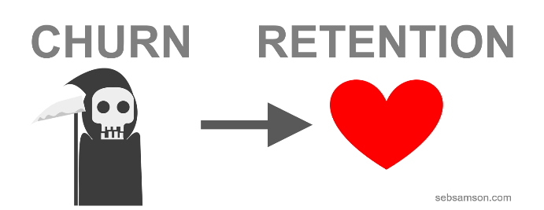  
 Churn = people don't come back :( , Retention = people come back :)

* Your Compulsion Loop : Anticipation to return to your project which includes the challenges and Rewards

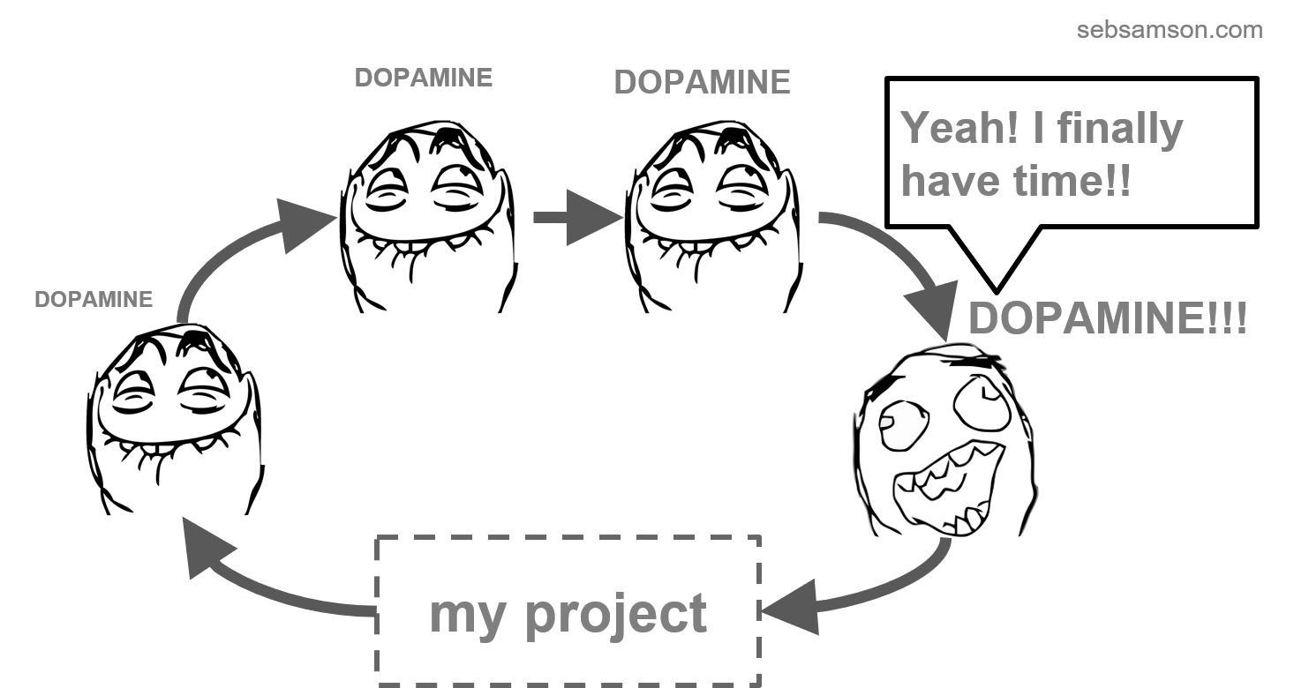

* **B**ehavior **= (M**otivation, **A**bility, **T**rigger)

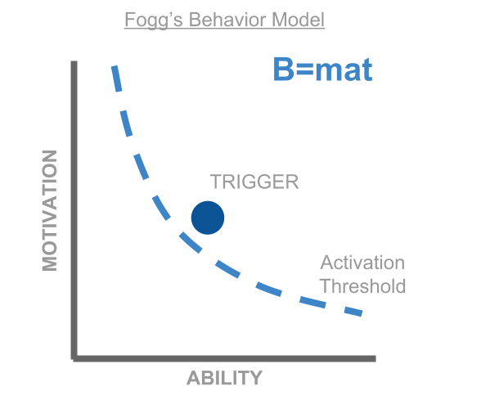

* There is no universal answer to what makes things meaningful for someone but you have to research your target audience and understand what interests them.
* It might not be related directly to what you want them to do at first but if you understand what is meaningful to them you might find something you can offer on the side that is worth their attention.
* ***Dopamine = Anticipation***